**Photographic Essay: Celebrating African Cultural Heritage and Identity**

Macharia Ronard Karimire

C025-01-2555/2020

Bsc. IT 4.2

Supervisor: Dr Maina

**Photographic Essay: Celebrating African Cultural Heritage and Identity**

**Introduction**

Africa, the cradle of humanity, is a continent of immense cultural wealth and diversity. From the ancient civilizations of Egypt and Ethiopia to the tribal communities of Nigeria and Kenya, Africa's cultural heritage is as varied as it is rich. Each region boasts its unique traditions, languages, and customs, shaped by centuries of history, migration, and interaction with neighboring cultures.

Despite the challenges of modernization and globalization, African cultural heritage remains a vibrant and integral part of the continent's identity. It is expressed through art, music, dance, cuisine, and rituals that have been passed down through generations, serving as a source of pride, identity, and community cohesion for African peoples.

This photographic essay aims to celebrate the beauty and resilience of African cultural heritage, showcasing the richness and diversity of traditions that continue to flourish across the continent. Through striking images and insightful captions, we invite you to embark on a visual journey through the vibrant tapestry of African cultures, from the colorful festivals of West Africa to the intricate beadwork of East Africa.

In West Africa, the rhythms of the djembe drum and the vibrant costumes of the Eyo festival in Nigeria reflect the region's rich cultural tapestry. In East Africa, the Maasai warriors of Kenya and Tanzania continue to uphold their traditional way of life, characterized by distinctive attire, beadwork, and warrior culture (Jethro, 2013).

Central Africa is home to a mosaic of cultures, including the pygmy tribes of the Congo Basin, whose unique hunter-gatherer lifestyle and spiritual beliefs have endured for thousands of years. In Southern Africa, the Zulu people of South Africa celebrate their cultural heritage through music, dance, and storytelling, keeping alive the traditions of their ancestors.

In North Africa, the ancient traditions of the Berber communities are reflected in their language, music, and cuisine, offering a glimpse into the region's rich cultural history. Across the continent, from the bustling markets of Ghana to the tranquil villages of Malawi, African cultural heritage is alive and thriving, a testament to the resilience and creativity of its people.

The preservation of African cultural heritage is not without its challenges. Rapid urbanization, environmental degradation, and the influence of Western culture pose threats to traditional ways of life. Yet, African communities continue to find ways to adapt and preserve their cultural heritage, often blending traditional practices with modern influences.

Through initiatives such as cultural festivals, museums, and educational programs, efforts are being made to safeguard African cultural heritage for future generations. These efforts are crucial not only for preserving the identity and traditions of African peoples but also for promoting cultural diversity and understanding on a global scale.

As we celebrate the beauty, diversity, and resilience of African cultural heritage in this photographic essay, we invite you to join us in recognizing the importance of preserving and honoring this heritage for the benefit of all humanity. Through the lens of photography, we hope to inspire a deeper appreciation for the richness of African cultures and the importance of cultural preservation in an ever-changing world.

**Cultural Festivals**

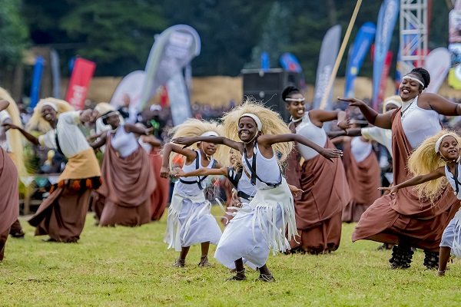

African cultural festivals are vibrant celebrations that showcase the diversity and richness of the continent's heritage. These festivals are often deeply rooted in tradition and serve as important occasions for communities to come together, celebrate their cultural identity, and pass down traditions to future generations.

The Durbar festival in Nigeria is one such celebration, where colorful parades, music, and dance are used to honor the Emir and display the cultural heritage of the Hausa people. Similarly, the Ashanti people of Ghana celebrate the Akwasidae festival, a time of thanksgiving and reflection, with processions, traditional rites, and the display of regal attire (Jethro, 2013).

In Ethiopia, the Timkat festival is a vibrant celebration of the Epiphany, where thousands of people gather to reenact the baptism of Jesus in the Jordan River. The festival features colorful processions, chanting, and the blessing of water, highlighting the strong religious and cultural traditions of the Ethiopian Orthodox Church.

In South Africa, the Cape Town Carnival is a modern take on traditional African festivals, featuring elaborate floats, costumes, and performances that celebrate the cultural diversity of the country. The carnival is a colorful spectacle that attracts thousands of spectators from around the world, showcasing the vibrancy and creativity of African culture.

The Festival Sur le Niger in Mali is a celebration of music, art, and culture that brings together musicians, artists, and performers from across the continent. The festival features traditional music and dance performances, as well as art exhibitions and cultural workshops, highlighting the diversity and richness of African cultural expression.

The Festival of the Desert in Mali is another renowned festival that celebrates the music, dance, and culture of the Tuareg people. The festival takes place in the Sahara Desert and features traditional music performances, camel races, and cultural exchanges, offering a unique glimpse into the nomadic way of life of the Tuareg people.

In Morocco, the Festival of World Sacred Music in Fez is a celebration of spiritual music and cultural exchange, featuring performances by musicians and artists from around the world. The festival promotes intercultural dialogue and understanding, highlighting the universal language of music as a means of bridging cultural divides.

The Festac Festival in Nigeria is a pan-African cultural festival that celebrates the cultural heritage of Africa and its diaspora. The festival features performances, art exhibitions, and cultural events that showcase the diversity and creativity of African culture, fostering a sense of unity and pride among participants.

In conclusion, African cultural festivals are vibrant celebrations that celebrate the diversity and richness of the continent's heritage. These festivals play an important role in preserving and promoting African culture, bringing communities together and fostering a sense of pride and identity among participants.

**Traditional Music and Dance**

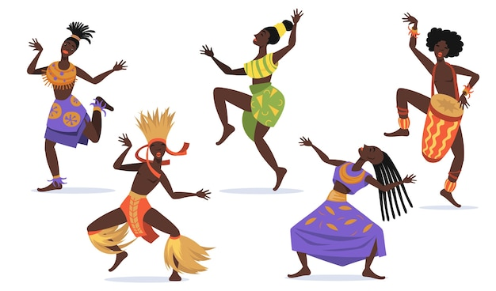

Music and dance are integral parts of African culture, serving as a means of communication, storytelling, and community bonding. Traditional African music is characterized by rhythmic beats, call-and-response vocals, and the use of drums, percussion instruments, and other traditional instruments such as the kora, balafon, and mbira (Primus & P, 2007).

In West Africa, the djembe drum is a popular instrument used in traditional music and dance. The rhythms of the djembe are energetic and lively, often accompanied by intricate dance movements that tell stories and convey emotions. The djembe is also used in ceremonies and celebrations, where its powerful sound is believed to connect the community with the spirit world.

In East Africa, traditional music and dance are an integral part of cultural celebrations and ceremonies. The Maasai people of Kenya and Tanzania, for example, have a rich musical tradition that includes vocal music, chanting, and the use of traditional instruments such as the orutu (a one-stringed fiddle) and the ngoma (a drum).

Central Africa is home to a variety of musical styles and traditions, including the vibrant music and dance of the Congo Basin pygmy tribes. Pygmy music is characterized by its use of vocal polyphony, with multiple voices singing different melodies simultaneously, creating a rich tapestry of sound that is unique to their culture.

In Southern Africa, traditional music and dance are an important part of cultural identity. The Zulu people of South Africa, for example, are known for their energetic dance styles such as the indlamu, a traditional Zulu dance performed by warriors to showcase strength and agility.

Traditional music and dance are also important in North Africa, where they are often influenced by Arabic and Berber traditions. In Morocco, for example, traditional music includes the use of instruments such as the oud (a lute-like instrument) and the qraqeb (metal castanets), accompanied by rhythmic dance movements that are both spirited and expressive.

Despite the influence of modernization and globalization, traditional music and dance continue to play a vital role in African communities, serving as a means of cultural expression, social cohesion, and identity. They are often passed down from generation to generation, preserving cultural heritage and ensuring that these rich traditions endure for future generations to enjoy.

In conclusion, traditional music and dance are integral parts of African culture, reflecting the continent's rich history, diversity, and creativity. They serve as a means of storytelling, community bonding, and cultural expression, highlighting the importance of preserving and celebrating these traditions for generations to come.

**Cuisine and Culinary Traditions**

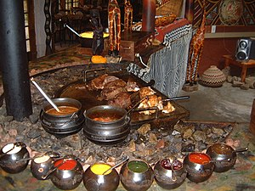

African cuisine is a reflection of the continent's diverse cultures and rich agricultural heritage. Each region has its unique culinary traditions, with dishes that reflect local ingredients, cooking methods, and cultural influences. From the spicy stews of North Africa to the hearty cassava-based dishes of Central Africa, African cuisine is as diverse as the continent itself.

In West Africa, the cuisine is characterized by bold flavors and spices. One of the most famous dishes is jollof rice, a flavorful dish made with rice, tomatoes, onions, and a variety of spices. Other popular West African dishes include fufu, a starchy dough served with soup or stew, and akara, fried bean cakes that are a popular street food.

East African cuisine is known for its use of spices and flavors. In Ethiopia, injera, a sourdough flatbread, is a staple food served with various stews and vegetables. In Kenya and Tanzania, pilau rice, a spiced rice dish often served with meat or vegetables, is a favorite dish for special occasions.

Central African cuisine is hearty and filling, with a focus on root vegetables, grains, and meats. In countries like Cameroon and the Democratic Republic of the Congo, dishes like ndole (bitterleaf stew) and fufu are popular staples. Palm oil is often used in cooking, giving dishes a rich and flavorful taste.

Southern African cuisine is influenced by a mix of indigenous, European, and Asian flavors. In South Africa, dishes like bobotie (a spiced minced meat dish) and pap (a maize porridge) are traditional favorites. In countries like Zimbabwe and Botswana, sadza (a thick maize meal porridge) is a staple food served with meat or vegetable dishes.

North African cuisine is known for its use of spices and flavors. In countries like Morocco, Tunisia, and Algeria, couscous is a staple food served with a variety of vegetables, meats, and sauces. Tagines, slow-cooked stews named after the earthenware pot they are cooked in, are also popular dishes in North Africa.

African culinary traditions are often passed down through generations, with cooking techniques and recipes preserved as part of cultural heritage. Many dishes are associated with specific rituals, ceremonies, and celebrations, highlighting the importance of food in African culture as a means of bringing communities together and preserving cultural identity.

In recent years, African cuisine has gained popularity worldwide, with African chefs and restaurants showcasing the continent's rich culinary traditions to a global audience. This growing recognition is not only a testament to the diversity and creativity of African cuisine but also an opportunity to celebrate and preserve these traditions for future generations to enjoy.

In conclusion, African cuisine is a vibrant and diverse reflection of the continent's rich cultural heritage. From the bold flavors of West Africa to the aromatic spices of North Africa, African culinary traditions are as diverse as the continent itself, serving as a source of pride, identity, and community bonding for African peoples around the world.

**Clothing and Adornments**

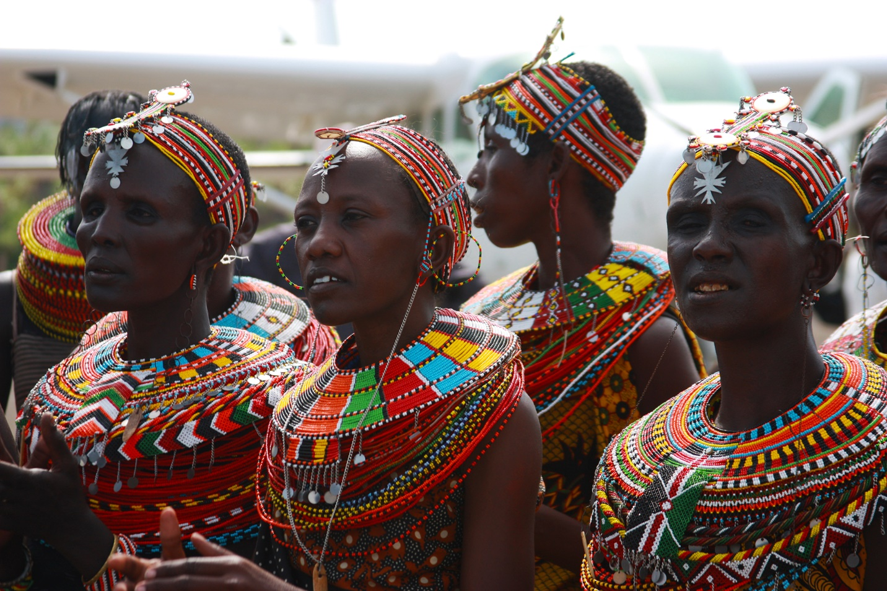

Traditional clothing and adornments play an important role in African culture, serving as a means of cultural expression, social status, and identity. Across the continent, each region and ethnic group has its unique styles and garments that reflect their cultural heritage and history.

In West Africa, traditional clothing often features brightly colored fabrics and intricate patterns. The kente cloth of Ghana, for example, is a handwoven fabric made from silk and cotton and is often worn during special occasions such as weddings, festivals, and ceremonies. The Yoruba people of Nigeria are known for their elaborate gele head wraps and agbada robes, which are symbols of status and cultural pride.

East African clothing is characterized by its use of vibrant colors and bold patterns. In countries like Kenya and Tanzania, the kanga is a popular garment worn by women. Kangas are rectangular pieces of fabric with colorful designs and Swahili proverbs printed on them, often used as wraps or headscarves (Primus & P, 2007).

Central African clothing is diverse, with each ethnic group having its traditional attire. In Cameroon, the toghu is a traditional outfit worn by the Bamileke people, consisting of embroidered robes and hats. In the Democratic Republic of the Congo, the Liputa is a traditional dress worn by women, featuring colorful fabrics and intricate beadwork.

Southern African clothing is influenced by both traditional and modern styles. In South Africa, the Xhosa people are known for their colorful beadwork and blankets, which are worn during ceremonies and celebrations. In Zimbabwe, the Shona people wear garments made from bark cloth, a traditional material that is both lightweight and durable.

Adornments such as jewelry, scarification, and body painting are also significant in African culture. Jewelry is often made from beads, shells, metals, and other materials, with each piece carrying symbolic meaning and cultural significance. Scarification, the practice of creating patterns and designs on the skin, is common in many African cultures and is often used as a form of body art and cultural identification.

In conclusion, clothing and adornments are important elements of African culture, serving as a means of cultural expression, social status, and identity. Through their traditional attire, African communities celebrate their heritage and history, preserving these rich traditions for future generations to appreciate and enjoy.

**Rites of Passage and Ceremonies**

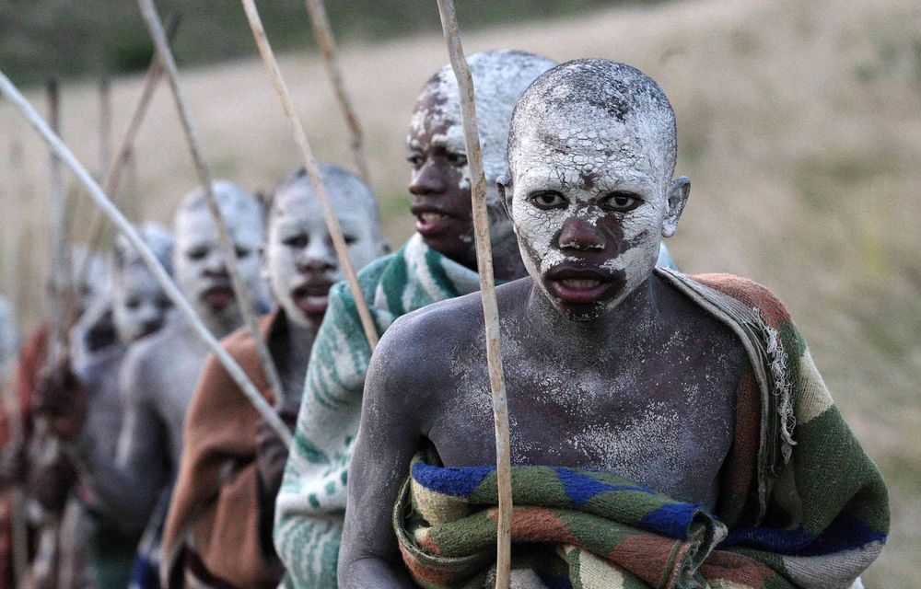

Rites of passage are important ceremonies in African culture, marking significant transitions in life such as birth, puberty, marriage, and death. These ceremonies are often elaborate and involve the entire community, serving to strengthen social bonds, transmit cultural values, and mark important milestones in an individual's life.

In many African cultures, birth is celebrated with rituals and ceremonies that welcome the new arrival into the community. Naming ceremonies are common, where the baby is given a name that reflects the circumstances of their birth or the hopes and aspirations of their parents. These ceremonies often involve prayers, blessings, and feasting, bringing together family and friends to celebrate the new life.

Puberty is another important stage in African culture, marking the transition from childhood to adulthood. In many cultures, puberty rites are elaborate and involve rituals and ceremonies that prepare young people for their roles as adults. These rites often include teachings on cultural values, responsibilities, and expectations, as well as physical tests and challenges to prove maturity and readiness for adulthood (Piert & J, 2007).

Marriage is a significant event in African culture, often involving elaborate ceremonies and celebrations that can last for several days. Marriage ceremonies vary widely across the continent, with each culture having its traditions and customs. In many cultures, marriage is seen as a union not only between two individuals but also between families and communities, and is accompanied by rituals and ceremonies that reflect this belief.

Death is also an important stage in African culture, marked by rituals and ceremonies that honor the deceased and comfort the living. Funeral rites vary widely across the continent, with each culture having its customs and traditions. In many African cultures, funerals are seen as a time of mourning but also as a celebration of the life of the deceased, with rituals and ceremonies that help the soul of the departed to find peace and rest.

In conclusion, rites of passage and ceremonies are important aspects of African culture, serving to mark significant transitions in life and strengthen social bonds within communities. Through these rituals, African communities pass down cultural values, beliefs, and traditions, ensuring that their rich heritage endures for future generations to appreciate.

**Language and Oral Tradition**

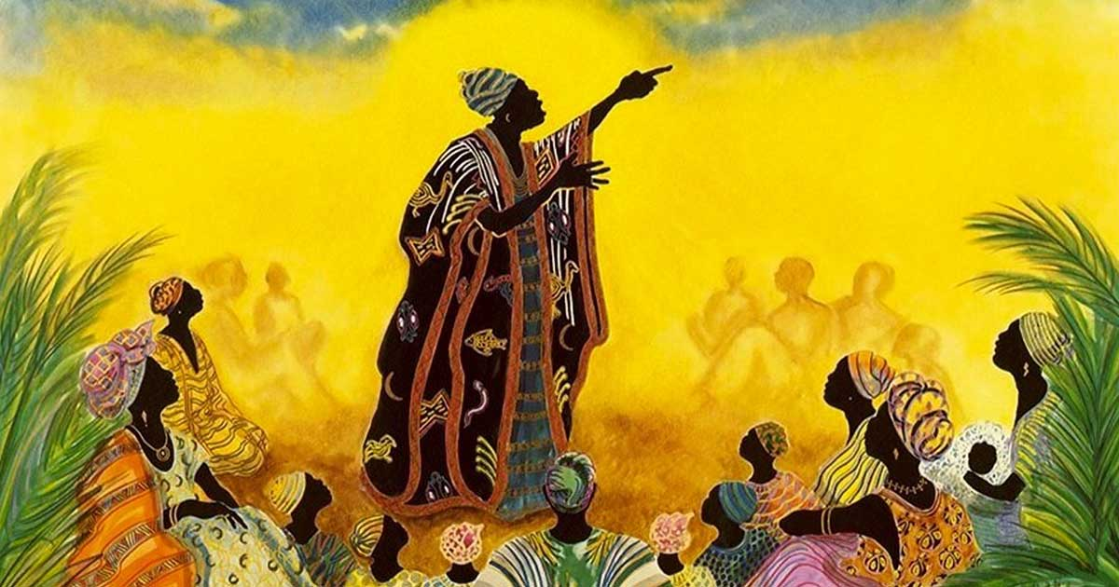

Language is an essential part of African culture, with thousands of languages spoken across the continent. Each language is a repository of cultural knowledge, beliefs, and traditions, passed down through generations through oral tradition (Eichler, 2021).

Oral tradition, including storytelling, proverbs, and poetry, plays a vital role in preserving African cultural heritage and passing on knowledge from generation to generation. Storytelling is used to teach moral lessons, impart wisdom, and preserve historical narratives, ensuring that important cultural and historical information is not lost.

Proverbs are another important aspect of African oral tradition, offering insights into cultural values, beliefs, and worldviews. Proverbs are often used to teach lessons, resolve conflicts, and convey complex ideas in a concise and memorable way, making them a valuable tool for communication and cultural preservation.

Poetry is also an important part of African oral tradition, with many cultures having rich poetic traditions that celebrate nature, love, history, and the human experience. Poems are often recited or sung during ceremonies and celebrations, serving to entertain, inspire, and educate listeners.

In many African cultures, griots or storytellers are revered members of society who are tasked with preserving and transmitting oral traditions. Griots are often skilled musicians, poets, and historians who use their talents to entertain, educate, and inspire their communities, ensuring that important cultural knowledge is passed down through generations.

In conclusion, language and oral tradition are integral parts of African culture, serving as a means of preserving and transmitting cultural knowledge, beliefs, and traditions. Through storytelling, proverbs, and poetry, African communities pass down their rich cultural heritage, ensuring that their traditions endure for future generations to appreciate and enjoy.

**Modern Influences and Globalization**



In recent years, African culture has been increasingly influenced by globalization, modernization, and technological advancements. While these changes have brought new opportunities and challenges, they have also led to concerns about the erosion of traditional cultural practices and values.

One of the most significant influences of globalization on African culture is the spread of Western media and entertainment. Western films, music, and fashion have become increasingly popular in Africa, leading to changes in cultural tastes and preferences. While this has led to greater cultural exchange and diversity, it has also raised concerns about the impact of Westernization on traditional African cultures.

Another influence of globalization on African culture is the rise of digital technology and social media. The internet and smartphones have connected African communities with the rest of the world, allowing for greater cultural exchange and communication. However, this has also led to concerns about the impact of digital technology on traditional forms of communication and social interaction.

Migration and urbanization are also significant factors shaping modern African culture. As more Africans move to cities and urban areas, they are exposed to new ideas, lifestyles, and cultures, leading to changes in traditional practices and values. Urbanization has also led to the growth of multicultural cities, where different ethnic groups and cultures coexist, creating new forms of cultural expression and identity.

Despite these influences, many African communities are working to preserve and promote their traditional cultural practices and values. Cultural festivals, museums, and educational programs are being used to safeguard African cultural heritage and ensure that it remains relevant and meaningful in the modern world.

In conclusion, modern influences and globalization are reshaping African culture in profound ways, bringing both opportunities and challenges. While these changes are inevitable, it is essential to recognize the importance of preserving and promoting traditional African cultures, ensuring that they continue to enrich the lives of African peoples and contribute to the diversity of the global cultural landscape.

**Conclusion**

In conclusion, African cultural heritage and identity are vibrant and diverse, reflecting the continent's rich history, traditions, and values. Through art, music, dance, cuisine, language, and oral tradition, African communities celebrate their heritage and pass down their cultural knowledge from generation to generation.

Despite the challenges of modernization, globalization, and technological advancement, African cultures remain resilient, adapting to change while preserving their unique identities. Cultural festivals, rites of passage, and ceremonies play a crucial role in maintaining these traditions, strengthening social bonds, and transmitting cultural values.

Language and oral tradition are integral to African culture, serving as vehicles for storytelling, proverbs, and poetry that convey moral lessons, wisdom, and historical narratives. Griots and storytellers play a vital role in preserving these traditions, ensuring that they continue to enrich African societies (Odunfa, et al., 1998).

In recent years, African culture has been influenced by globalization, leading to greater cultural exchange and diversity. While this has brought new opportunities and challenges, it has also raised concerns about the preservation of traditional practices and values. Efforts to safeguard African cultural heritage, such as cultural festivals, museums, and educational programs, are essential for ensuring that these traditions endure for future generations.

As Africa navigates the complexities of modernity and globalization, it is crucial to recognize the importance of preserving and promoting its cultural heritage. African culture is not only a source of pride and identity for its people but also a valuable contribution to the diversity of the global cultural landscape. By celebrating and preserving African cultural heritage, we can ensure that these rich traditions continue to inspire and enrich us all.

**References**

Eichler, J. (2021). Intangible cultural heritage, inequalities and participation: who decides on heritage?. *The International Journal of Human Rights*, *25*(5), 793-814.

Herwitz, D. (2012). *Heritage, culture, and politics in the postcolony*. Columbia University Press.

Jethro, D. (2013). An african story of creation: heritage formation at freedom park, south africa. *Material Religion*, *9*(3), 370-393.

Odunfa, S. A., & Oyewole, O. B. (1998). African fermented foods. *Microbiology of fermented foods*, 713-752.

Piert, J. H. (2007). Transition into adulthood: The experience of a rite-of-passage program at an African centered high school. *Negro Educational Review*, *58*(3/4), 169.

Primus, P. (1996). African dance. *African dance: An artistic, historical and philosophical inquiry*, 3-11.